Boundary condition effects on saturation and pressure behavior:

Net heterogeneity models:

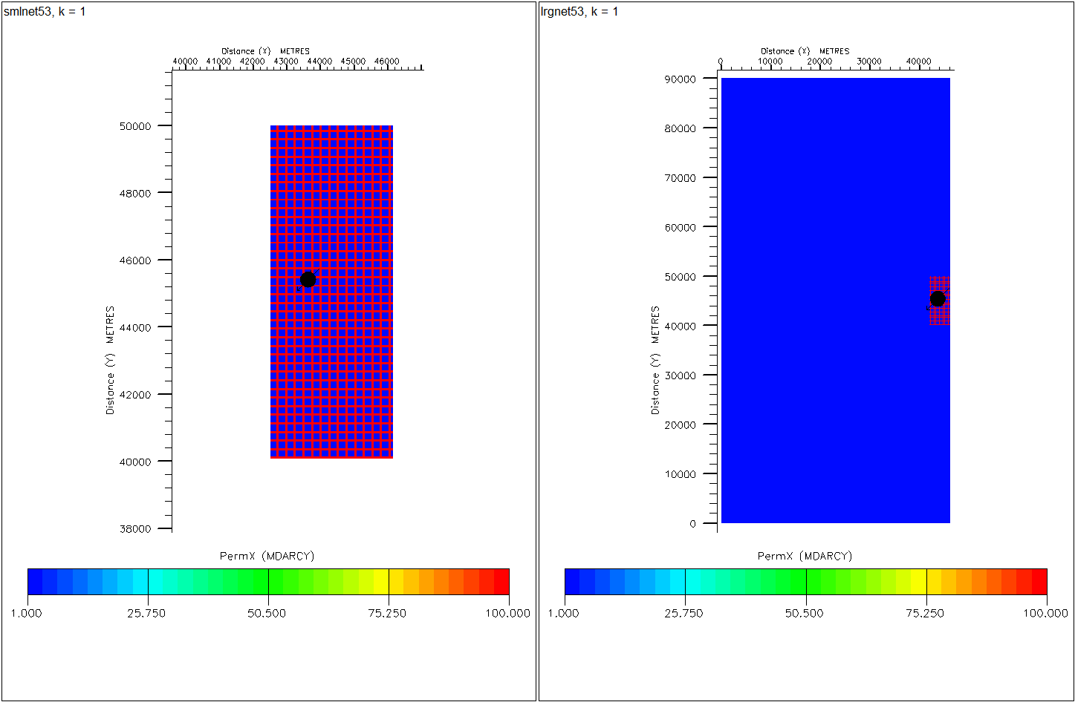

* The well is completed in K=1 mD. The channels range vary in permeability verses different models: 0.1,1,10,100 mD.
* Large and small models are compared for results.
* The small models are in the scale of SAIGUP models and the volume at the boundaries are multiplied by numbers to be equal to the boundaries used in SAIGUP models for our study.
* CO2 saturation and pressure is compared between large and small scale models.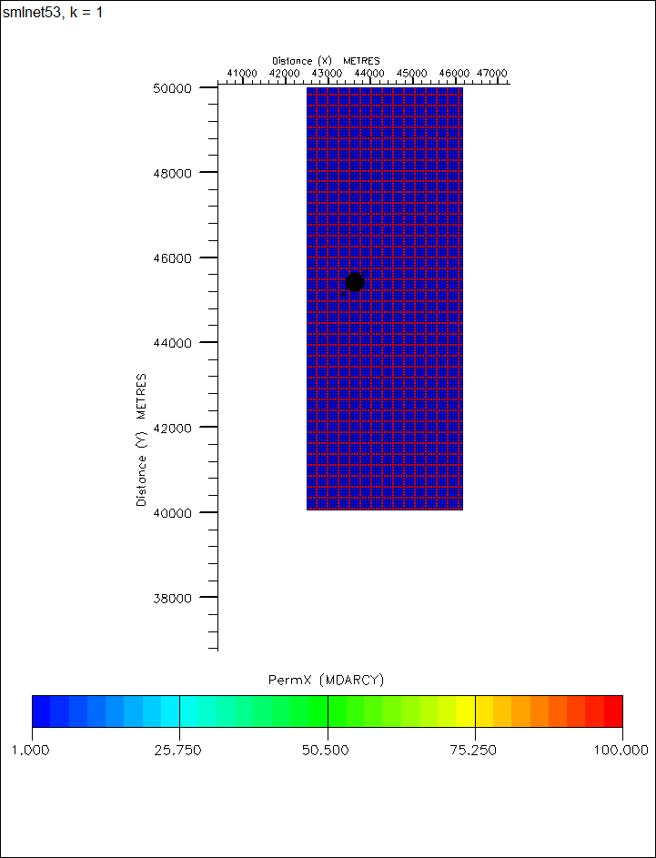
* The results are plotted for one dimension from the well to the side of the model, shown by yellow ellipse.
* Results for CO2 versus radius around the well:C:\Users\meisama\Documents\PhD\InjectionPressure\PICs\co2vsr.eps

Permeability in the channels:

Blue: 0.1 mD

Green:1 mD

Yellow: 10 mD

Red: 100 mD  
Solid lines for large model  
Dashed lines for small model

* Results for pressure versus radius:
* C:\Users\meisama\Documents\PhD\InjectionPressure\PICs\prsVsR.eps

Permeability in the channels:

Blue: 0.1 mD

Green:1 mD

Yellow: 10 mD

Red: 100 mD  
Solid lines for large model  
Dashed lines for small model